Block Ram Image Viewer
By Zoltán Ulrich

Submitted for the second edition
of the Digilent Digital Design Contest
October 1, 2006

Instructor: Prof. Dr. Ing. Mircea Dăbâcan
Technical University of Cluj Napoca

Contents
3

4
4
6
7
9
9
9
10
12
12
13
14
16
18
18
20
22
23

24

25
- Introduction

- Design
  - Top Level Block
  - Epp Controller
  - Command Dispatcher
  - Resolution Switcher
  - Request Controller
  - PS/2 Interface
  - Keyboard Controller
  - DCM Module
  - Pixel Clock Switcher
  - Hex Decoder
  - VGA Module
  - Mouse Controller
  - Resolution Mouse Informer
  - Mouse Displayer
  - Image Controller
  - Image Motion Controller
  - Effects Layer

- Discussion

- References

1. Introduction

This report presents the design of an image displaying and manipulating unit for the Digilent Nexys Board, that receives the images from a connected computer, stores then entirely in block ram memory and displays then using a 12 bit vga module on a CRT monitor. The images can be displayed using two available resolutions, namely 640x480@60Hz and 800x600@60Hz, are received through the epp interface from the computer, can be moved on the screen using a connected ps/2 compatible mouse and negative and grayscale effects can be applied to the displayed image using a ps/2 compatible keyboard. Using the keyboard, or from the computer software application, the user can change the displayed image by requesting the next or previous image in the current directory and can start and stop a live feed from a connected webcam if available.

The unit is defined in VHDL, and it targets a Xilinx Spartan-3 FPGA. Some of the modules, like the ps2 interface, mouse controller and keyboard controller are generic and can be easily reused without changes in other designs. The circuit was designed on a Windows XP PC using Xilinx WebPack 7.1.04i CAD tool and simulated using ModelSim XE Starter 6.0d.

Required tools:
- Digilent Nexys 200K (or greater) board.
- Digilent VGA Module for the Nexys board
- 2 Digilent PS/2 modules
- CRT Monitor
- PS/2 compatible mouse (extra functionality if has wheel)
- PS/2 compatible keyboard
- Digilent Adept Suite
- PC running OS Windows XP Service Pack 1 (or greater)
- Microsoft WIA Library v2.0
- Microsoft .NET Framework 2.0
- Optionally a WIA compatible webcam
2. Design

The top level block is a schematic file, as are most of the modules that appear on the top level schematic sheet. Low level modules are written in VHDL and are generously commented.
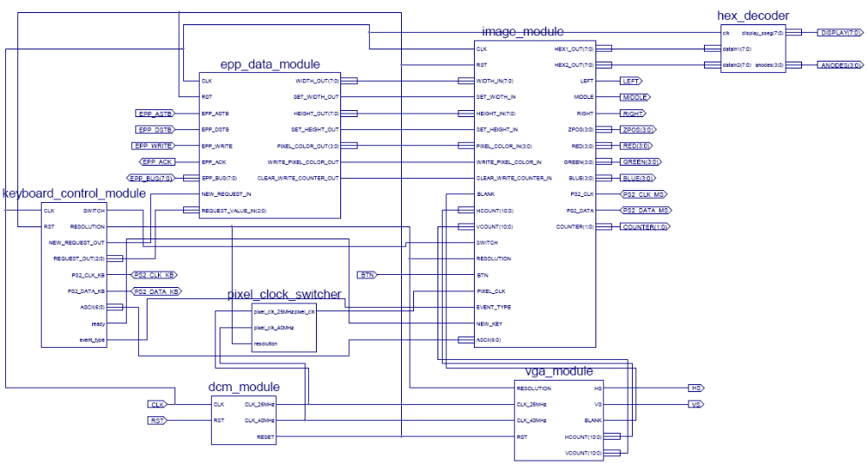
Table 1. Top Level I/O pins

Pin Name | Pin Direction | Description
CLK | Input | Global clock line, from board oscillator. Frequency: 100MHz
RST | Input | Reset input from button 0 of the board.
BTN | Input | Button 1 from the board, used to change the data shown on the 7 segment displays
EPP_ASTB | Input | Address strobe from the USB controller, simulating the epp interface
EPP_DSTB | Input | Data strobe from the USB controller, simulating the epp interface
EPP_WRITE | Input | Write cycle from the USB controller, simulating the epp interface
EPP_ACK | Output | Wait signal from the USB controller, simulating the epp interface
EPP_BUS<7:0> | Bidirectional | The epp interface bus, 8 bits width
PS2_CLK_KB | Bidirectional | Clock line from the ps/2 keyboard
PS2_DATA_KB | Bidirectional | Data line from the ps/2 keyboard
PS2_CLK_MS | Bidirectional | Clock line from the ps/2 mouse
PS2_DATA_MS | Bidirectional | Data line from the ps/2 mouse
ANODES<3:0> | Output | Signal that controls which 7 segment display is currently active
DISPLAY<7:0> | Output | Data to be shown on the currently active 7 segment display
COUNTER<1:0> | Output | Value of counter that selects which bound of the image to be displayed on the 7 segment displays. Tied to LEDs 7 and 6.
LEFT | Output | State of the left mouse button, tied to LED 0
MIDDLE | Output | State of the middle mouse button, tied to LED 1
RIGHT | Output | State of the right mouse button, tied to LED 2
ZPOS<3:0> | Output | Delta movement of the mouse wheel, bits 2:0 tied to LEDs 5:3
RED<3:0> | Output | Value of red color channel that is sent to the monitor
GREEN<3:0> | Output | Value of green color channel that is sent to the monitor
BLUE<3:0> | Output | Value of blue color channel that is sent to the monitor

Table 2. Modules on the top level schematic

Module Name | Description
epp_data_module | This module handles the communication through the epp interface with the software running on the computer. It receives the images together with their width and height and forwards the data to the appropriate module.  It also receives and stores requests from the keyboard control module until they are sent to the computer when it polls for requests.
keyboard_control_module | Generates requests made by the user using the keyboard and forwards them to the epp_data_module. Also, enables the user to change the display resolution using key combinations and forwards key events (ASCII code and event type) to other modules that need this information (effects_layer module).
pixel_clock_switcher | VHDL written module. Switches between two clock signals, generated by two DCM device primitives. The selecting signal is the used resolution (‘0’ for 640x480 and ‘1’ for 800x600). Switching is done using a BUFGMUX device primitive.
dcm_module | Contains code to instantiate 2 DCM device primitives when generate clock signals from the system clock of 100MHz. The DCMs generate a 25MHz clock and a 40MHz clock, used as pixel clocks for the selectable resolutions. Also provide the global reset signal. Until the DCMs lock the clock signal, reset is asserted to keep the design from functioning without stable pixel clocks.
hex_decoder | VHDL written module. Generates ANODES and DISPLAY signals that control the 7 segment displays. Data to be displayed is input on the datain1 and datain2 inputs.
vga_module | Contains the two vga controllers that generate the synchronization signals for the monitor, the pixel horizontal counter, the vertical lines counter and the blank signal that is used to disable color output when the current pixel is not in the visible area (beam returns to left side or top of the screen). Signals to be used by the rest of the design are selected using the resolution signal.
image_module | This is the most complex module in the design. It stores the received image from the epp_data_module, displays it on screen, manages its movement and applies effects to it (negative, grayscale or both). It also contains the mouse module and the cursor displayer.

The epp_controller module implements the enhanced parallel port protocol to exchange data with the software running on the computer. Data sent by the computer is forwarded to the command_dispatcher module using 3 signals: epp_adr_out<7:0> which is the address the data was received on (before sending data, the computer executes an address write cycle and the epp_controller stores the address in an internal register that is output on epp_adr_out), epp_data_out<7:0> the byte received from the computer and write_out, which is active for one clock period when new data is available on epp_data_out together with the receiving address on epp_adr_out.
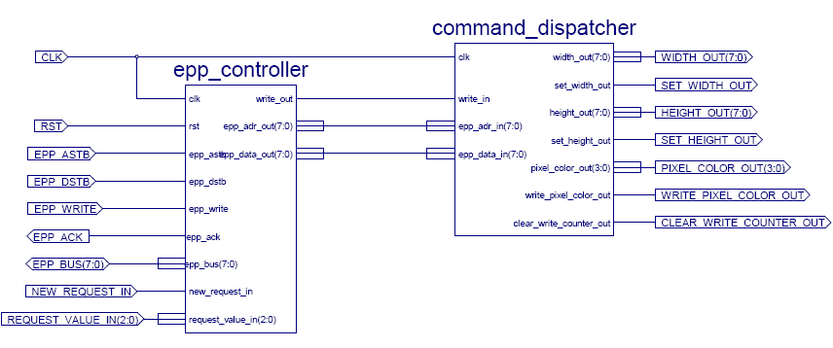
Figure 2. epp_data_module schematic

Requests are made to the computer and registered with the epp_controller by placing the code of the request on the request_value_in<2:0> pins and activating the new_request_in signal for one clock period. On the rising edge of the clock, if new_request_in is high, then the value on request_value_in is stored in an internal register. The software on the computer periodically polls the epp_controller for new requests, by performing a read data cycle. Once the request has been sent to the computer, the register that holds the request is cleared. If no request is issued and the computer reads the request register, then it will read the 00h value, which it interprets as no request.

Valid request codes are:
1h – send next image in the current directory
2h – send previous image in the current directory
3h – start live video feed
4h – stop live video feed

The reader must understand how the epp protocol works for grasping the inner workings of the epp_controller. The following article on the web explains the epp protocol:
http://www.beyondlogic.org/epp/epp.htm

For implementing the epp protocol, the controller uses a finite state machine with 9 states; hand encoded using 4 bits using almost gray coding. Almost, because a few transitions break the gray coding rule, but these transitions occur rarely (read address cycle that should never occur and the read data cycle). The states diagram for this finite state machine is presented on the following page.

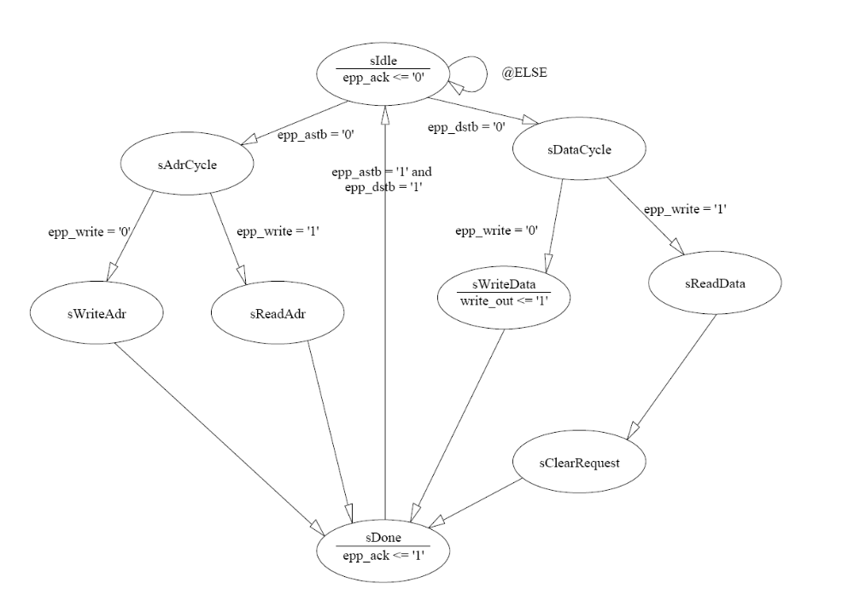
Figure 3. epp_controller state diagram

The command_dispatcher module receives data from the epp_controller, interprets it and generates commands for its clients (image_controller and image_motion_controller). When receiving an image, the computer first sends the width of the image, then the height and then sends the actual image pixels, one color channel at a time. Before sending actual data, like the width of the image, the height and the pixels, the computer first sends a byte on a dedicated address that represents the tag of the following byte. Tags are sent on address 255 and actual data that follows is sent on address 170. When sending the pixels, it would be inefficient to write a tag before each byte sent, so the tag is sent before the first byte saying that the pixels follow and then all the pixels are sent in a consecutive manner. When all the pixels have been sent, the stop image tag is sent on the tag address (255).

For example, when sending a 120 by 80 pixels image the following data is sent:

Data Address
1. 0 (COMMAND_RECV_TAG_WIDTH) 255 (COMMAND_RECV_TAG_PORT)
2. 120 (the actual width) 170 (COMMAND_RECV_DATA_PORT)
3. 1 (COMMAND_RECV_TAG_HEIGHT) 255 (COMMAND_RECV_TAG_PORT)
4. 80 (the actual height) 170 (COMMAND_RECV_DATA_PORT)
5. 2 (COMMAND_RECV_TAG_START_IMAGE) 255 (COMMAND_RECV_TAG_PORT)
6. blue0 (blue channel of first pixel) 170 (COMMAND_RECV_DATA_PORT)
7. green0 (green channel of first pixel) 170 (COMMAND_RECV_DATA_PORT)
8. red0 (red channel of first pixel) 170 (COMMAND_RECV_DATA_PORT)
9. blue1 (blue channel of second pixel) 170 (COMMAND_RECV_DATA_PORT)
10. green1 (green channel of second pixel) 170 (COMMAND_RECV_DATA_PORT)
11. red1 (red channel of second pixel) 170 (COMMAND_RECV_DATA_PORT)
...
28805. red9599 (red for last pixel) 170 (COMMAND_RECV_DATA_PORT)
28806. 3 (COMMAND_RECV_TAG_STOP_IMAGE) 255 (COMMAND_RECV_TAG_PORT)
When receiving pixel bytes from the computer, for each byte received (for each color channel) only the most significant 4 bits are retrieved and sent to the image_controller, since the image stored has 12 bit pixels, 4 bit for every color channel. At the beginning of receiving another image, the output clear_write_counter_out is set high for one clock period to reset the write memory counter in the image_controller module.

To handle the transfers, the command_dispatcher uses a finite state machine with 4 states. The diagram is presented bellow.

Figure 4. command_dispatcher state diagram
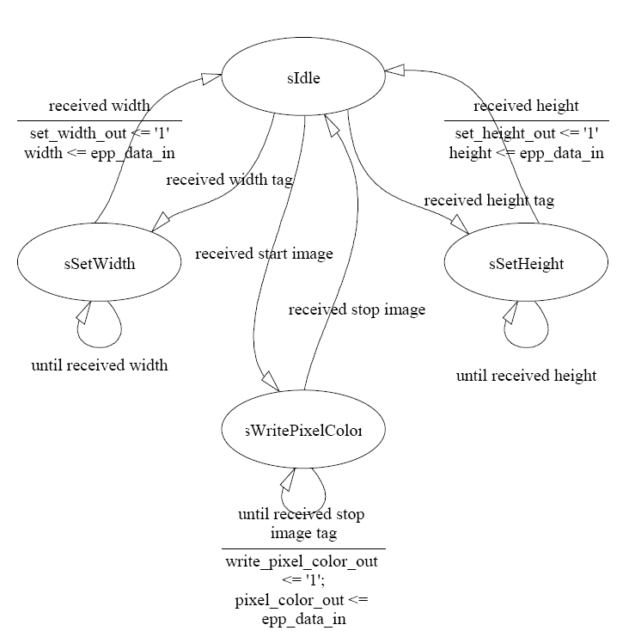

Figure 5. keyboard_control_module schematic

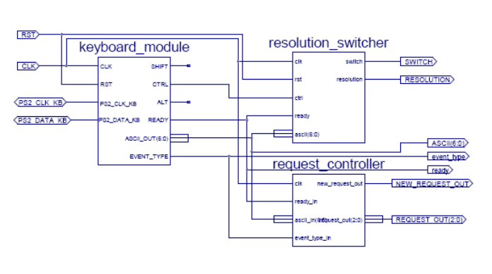

The keyboard_control_module is comprised of the keyboard_module, the resolution_switcher and the request_controller. Both resolution_switcher and the request_controller are low level modules, written in VHDL and use key events to change the resolution and to issue requests to the computer through the epp_data_module. The keyboard_module is a schematic that houses the keyboard_controller and the ps2interface for the keyboard.
The resolution_switcher changes the selected resolution by changing the value on the resolution signal when a key combination is pressed. For selecting the 640x480 resolution the user presses ctrl + 1 and for the 800x600, ctrl + 2 must be pressed. When the resolution changes, the switch output signal goes high for 1 clock period, so the modules using the resolution signal know that its value has changed. Actually, even when switching to the same resolution, the switch output will become high for one clock period.

The request_controller module, issues requests to the computer depending on the keys pressed. Thus, when pressing the SPACE key, the fetch next image request will be registered with the epp_controller. When BACKSPACE is pressed, fetch previous image will be issued. Q generates the start video request and A generates stop video request. For understanding how the request mechanism works, please read above at epp_controller description and the comments in the request_controller source file.

Figure 6. keyboard_module schematic
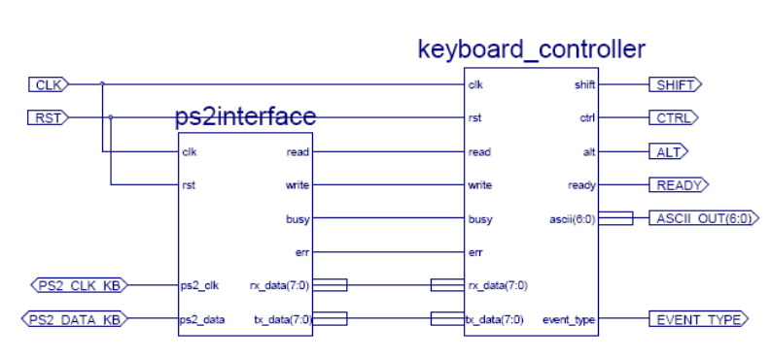

The ps2interface is a generic interface for any ps/2 compatible device. To understand the how the ps/2 protocol works, please read the following article on the web:
http://www.computer-engineering.org/ps2protocol/
Also the source file for the ps2interface, is thoroughly commented.

The ps2interface module, is a low level module and is written in VHDL. It implements a bidirectional interface with the ps/2 device and provides an easy interface for its clients. Received data is output on the rx_data output pins and activates the read output for one clock period. To send a byte to the device, the client places the desired byte on the tx_data inputs and activates the write input for one clock period. The write input can be held active for more than one clock period, but if it is held in this state for more then it takes to send the byte, the ps2interface will send the byte again.
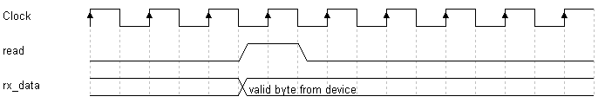
Figure 7. receive data from device timing diagram
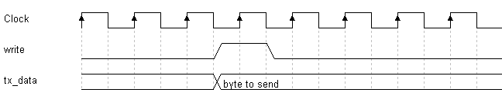
Figure 8. send data to device timing diagram
The keyboard_controller is a client for the ps2interface. It is a low level module, written in VHDL. Can be easily reused in other designs, it is not dependent in any way on the project. It provides an easy to use interface to its clients.

To understand how to interface a ps/2 compatible keyboard please read the following article on the web:
http://www.computer-engineering.org/ps2keyboard/

Its outputs are:

- shift - state of the shift key (left or right). It is high when shift key is pressed and low when it is not pressed.
- ctrl - state of the control key (left or right). It is high when control key is pressed and low when it is not pressed.
- alt - state of the alt key (left or right). It is high when alt key is pressed and low when it is not pressed.
- ascii_out<6:0> - the ASCII code of the last key pressed, held down or released. If the key has no corresponding ASCII code, 0 is output on this port. If the shift key has held down when pressing the key, then the ASCII code is the code of the character activated by the shift key. For example: if pressing key 2 while holding down the shift key, the ASCII code of character “@” is output.
- ready - active for one clock period when a new key event occurred and validates data on ascii_out.
- event_type – gives the type of the key event occurred. For a MAKE event (a key was pressed or held down) it is low and for a BREAK event (a key was released) it is high. Its state should be read when ready is high.

The keyboard_controller keeps track of the state of the leds on the keyboard, and when num lock, caps lock or scroll lock is pressed, it toggles the state of the leds, by sending the keyboard the set_leds command, followed by the byte with the actual state of the leds. If the num lock key (or caps or scroll) is held down, the state of the leds does not change because the controller verifies if the BREAK event occurred for this key.

After every byte the keyboard receives, it send the acknowledge byte (FAh) to the host (the controller). If the acknowledge is not received at some point, the controller enters reset state. When the board is powered up or when the reset button is pressed or some error occurs, the keyboard controller enters reset state and begins the initialization procedure for the keyboard. The procedure consists of sending the reset command to the keyboard. Then receiving the BAT test (Basic Assurance Test) result (after receiving acknowledge for the reset command). If the test is successful AAh is received as the result. Then the set typematic rate and delay command is sent followed by the typematic rate and delay actual value, which is byte 0Dh meaning 10cps and 0.25s delay. When this is done, the keyboard controller finite state machine enters idle state where it waits for a key event to occur. When the event occur, depending on the received byte, it transitions in other state where the complete scan code is received, analyzed and, if the case, the ASCII code is output together with the event type.

If key events for keys that do not have a corresponding ASCII value (like F1, or left arrow) are required, then the controller can be easily changed to output the scan code received, or to incorporate additional logic together with additional output signals. An interesting thing to note is that all the scan codes have the last byte in the range 00h-7Fh, meaning they can be represented using 7 bits. Only the F7 key has the scan code of 83h. For this reason, the translation from scan code to ASCII code is done by using a 256x7 bits ROM. The ROM address is composed as follows: least significant 7 bits are the corresponding 7 bits from the received scan code and the most significant bit is the state of the shift key. This way, the ROM is divided logically in two halves, the first half has the ASCII codes for the characters generated when shift is up, and the second half has the codes of the characters generated when shift is held down (characters like “@”,”F”,”:”,”\””). Another interesting thing is that the PAUSE/BREAK key has a very complex MAKE scan code, entirely different from all the other keys: E1, 14, 77, E1, F0, 14, F0, 77. Also, this key does not have a BREAK scan code. It is impossible to tell when it is released. Support for this key is not implemented in the controller. The state diagram for the finite state machine in the keyboard_controller is presented bellow.
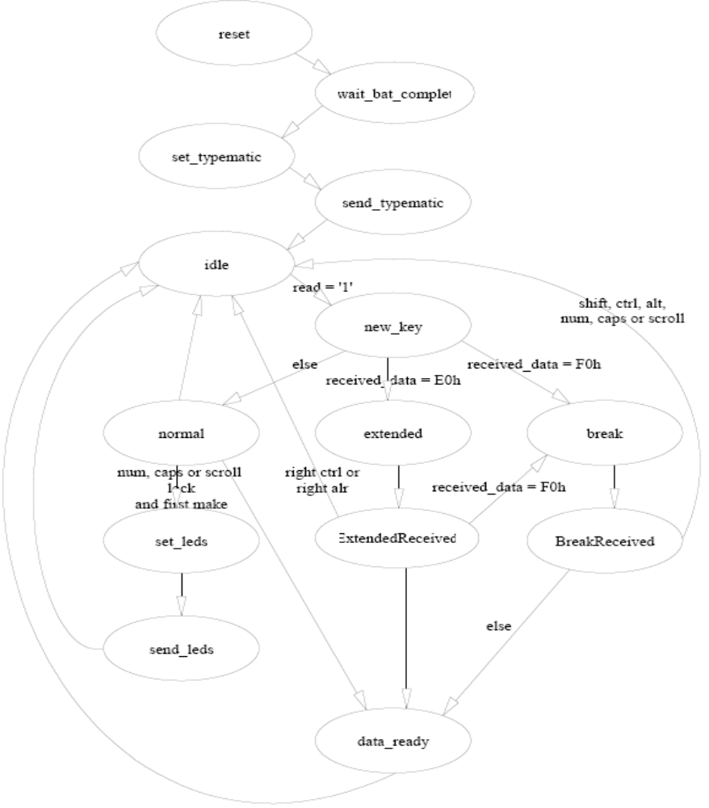
Figure 9. keyboard_controller state diagram

Note: not all states have been pictured, because state machine is complex and the diagram would confuse more than serving its purpose of clarifying things. States that wait for acknowledge were left out and also states that wait for the ps2interface to be idle. Also, from every state that waits acknowledge and the bat completion state, if and error occurs or the wrong data is received, there is a transition to the reset state. For a detailed explanation of how the keyboard controller works please see the comments in its source file.
. DCM Module schematic
Figure 10. DCM Module schematic
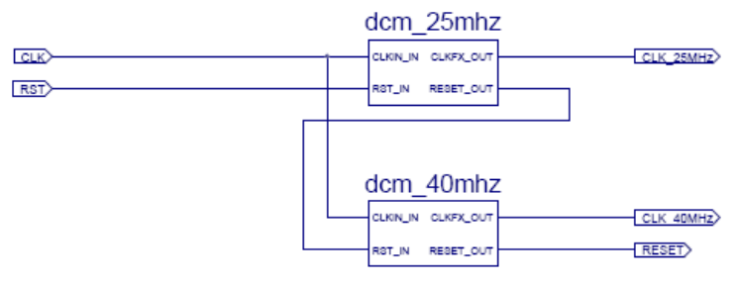

The DCM Module generates the two pixel clocks of 25MHz, for the 640x480@60Hz resolution and 40MHz, for the 800x600@60Hz resolution. This module also provides the global reset signal. For generating the clocks, DCMs (Digital Clock Managers) are used, with no feedback, which receive the system clock and the reset signal as inputs and output two signals: the CLKFX_OUT that is the pixel clock signal and the LOCKED_OUT which is high when the pixel clock output is stable and is ready to use.

For preventing the logic from functioning while the pixel clocks are not stable, the LOCKED_OUT signal of the first DCM is inverted and passed as the reset input to the second DCM. The LOCKED_OUT output of the second DCM is inverted and used as the global reset signal. This way, while the first DCM doesn’t have a stable clock output, the second DCM and the rest of the logic is in reset state. After the first DCM locks the clocks, the second DCM initializes and holds the logic in reset state until it also locks the clock signal. This is how multiple DCMs are chained together. The clock lines provided by the DCMs are not buffered, but after passing through the BUFGMUX in the pixel_clock_switcher module, the selected pixel clock will use a global clock line.

The Spartan-3 fpga with 200kgates (like the one this design is intended for) has 4 DCMs, one in each corner of the chip. The used DCMs were placed manually by attributes in the code for trying to achieve a minimum path from the DCM output to the vga_controller that uses the clock line and the BUFGMUX used to switch the clock.

attribute loc: string;
attribute loc of DCM: component is "DCM_X0Y1"; -- DCM in the upper-left corner

The pixel_clock_switcher module is a low level module and it is written using VHDL. Its sole purpose is the select the currently used pixel clock line depending on the selected resolution. Clock switching is a pretentious process and a BUFGMUX device primitive is used to select between the input clock lines.

BUFGMUX device primitives have rather restrictive using conditions, that’s why only two resolutions are offered to the user. Up to four resolutions could be used, but manual placing with FPGA Editor or other such editors might be necessary. For details, please read Global Clock Network section from the Spartan 3 Data Sheet, on page 39.

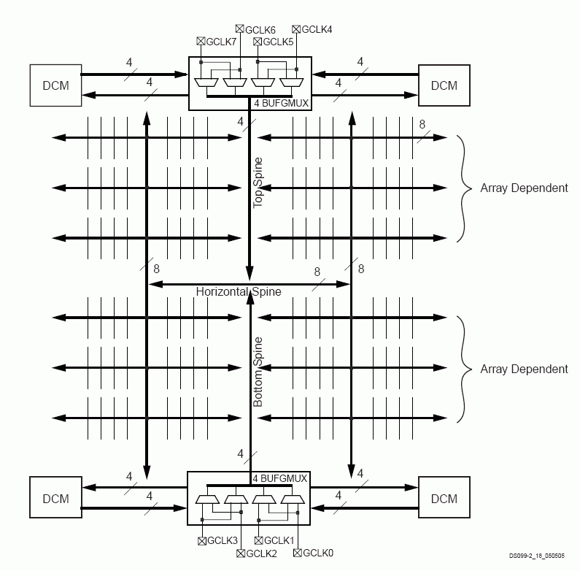
Figure 11. The Global Clock Network
The hex_decoder module is a low level module, written using VHDL, and its purpose is to display on the 4 7-segment displays data received on its input pins. The refresh rate used for display is 47.68Hz and each digit is active for 5.24ms. This way the display will not flicker.

It receives as data inputs 2 8-bit width signals, named datain1 and datain2. The value of datain1 will be displayed on the rightmost 2 digits and the value of datain2, on the leftmost 2 digits.

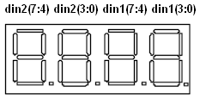
Figure 12. datain to digits mapping

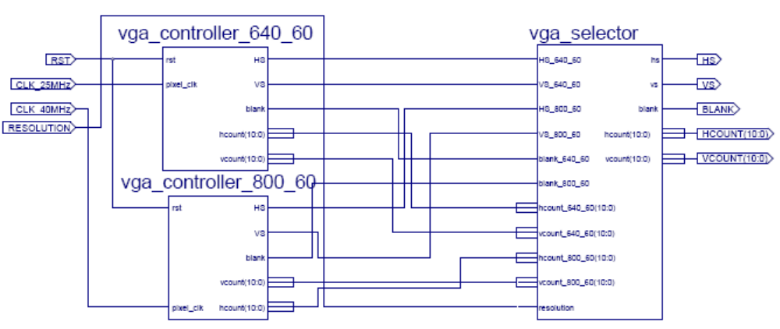
Figure13. vga_module schematic

The vga module has as inputs the reset signal, the pixel clocks and the resolution and it outputs the horizontal and vertical synchronization signals (used by the monitor), the horizontal and vertical counters that specify which pixel is currently being displayed and the blank signal that is active when pixel is not in the visible screen area (beam returning to the left side of the screen, or to the top). The vga controllers are used for the two selectable resolutions, and each produces independently its output signals. The signals to be passed to the rest of the logic are selected by the vga_selector, based on the current value of the resolution signal.

The vga_controller_640_60 uses the 25MHz clock line, the other being used by the vga_controller_800_60. For the vga timings, please read the following article on the web:
http://www.epanorama.net/documents/pc/vga_timing.html

The 640x480 vga controller uses a negative synch pulse polarity for both hs and vs, and the 800x600 vga controller uses positive synch pulse polarity for both these signals.

Figure 14. 640x480 timing
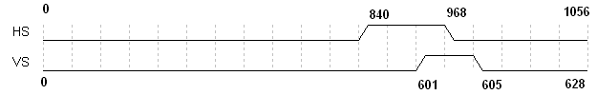
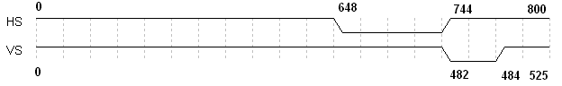
Figure 15. 800x600 timing

The blank output signal is delayed 1 pixel clock width from when it should be put high according to the counters, to account for the pixel pipeline delay, because of the time it takes to read the pixel from memory.
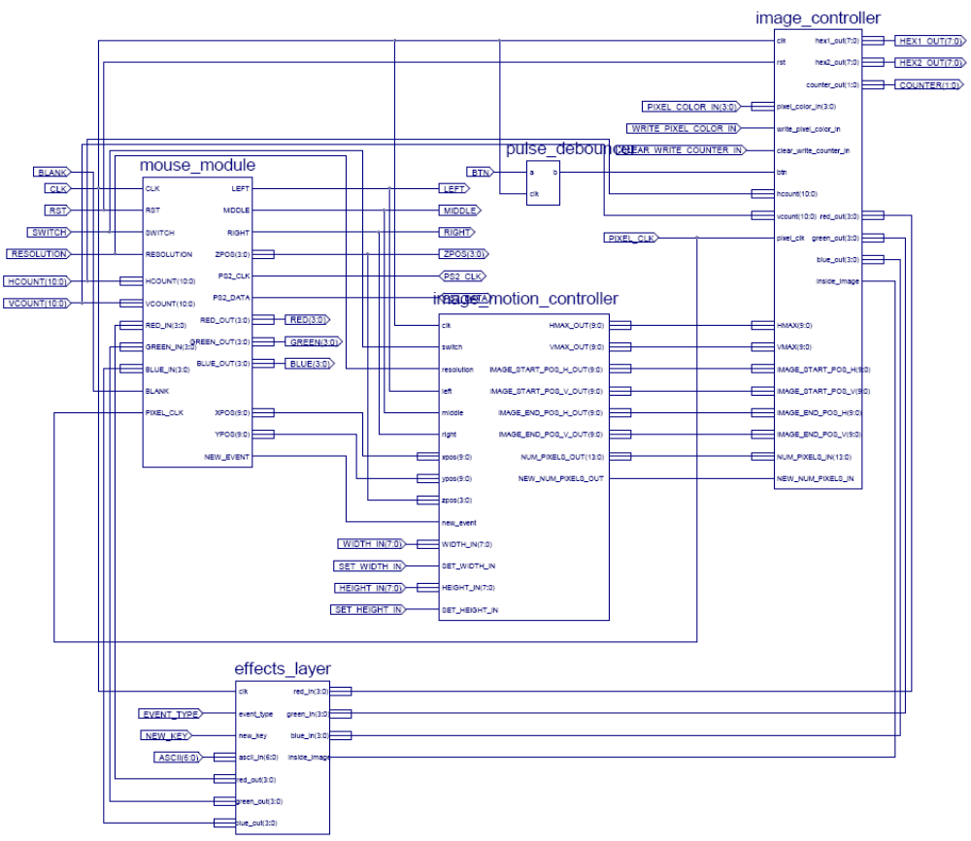
Figure 16. image_module schematic
The image module is the most complex module of the design and consequently it accounts for most of the project resources. It is responsible for storing the image, displaying the image, applying effects to it, implements a mouse controller, displays a cursor for the mouse and manages the image position on the screen.

The image controller is a low level module, written in VHDL, and is responsible for storing the image, sending the pixel data for display when the counters from the vga module are inside the bounds of the image specified by the image_motion_controller.

The image_motion_controller is written in VHDL and it manages the position of the image on the screen. When the resolution changes, it centers the image, when new image is received, using the received width and height it centers the image, when the mouse drags the image or moves it using the mouse wheel it modifies the image position accordingly without letting the image to leave the screen.

The effects_layer applies negative, grayscale or both effects to the image on a pixel by pixel basis. This means that the effects applied are not persistent, they only apply to the image sent to screen, and data in the image memory does not changed. To store the changed image, a larger memory would be necessary, or the image would have to be smaller. Effects to be applied are selected through the keyboard.

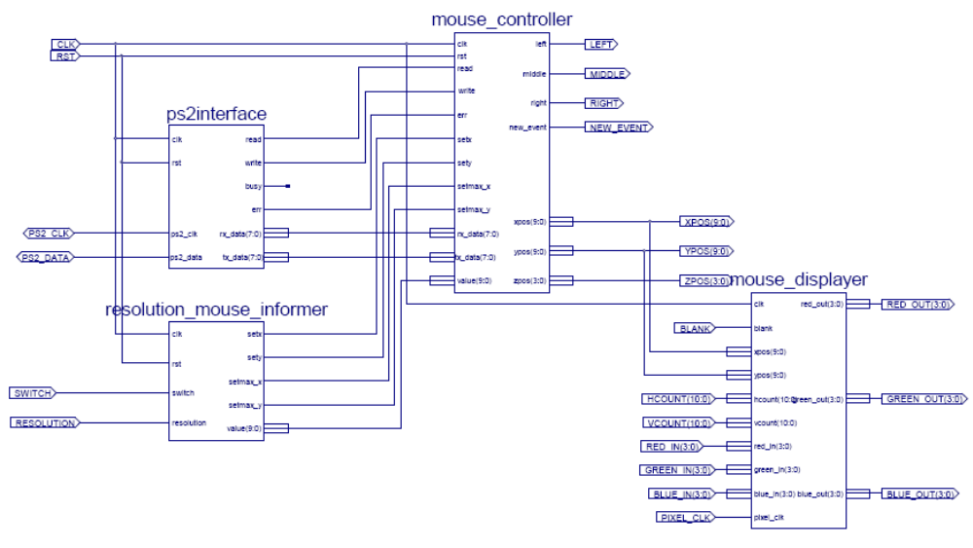
Figure 17. mouse_module schematic

The mouse module contains the generic ps2interface (another instance of the same interface as used in the keyboard_module), the mouse_controller (that acts as a client to the ps2interface, just like the keyboard_controller), the resolution_mouse_informer (that sets the mouse position and bounds when the resolution changes) and the mouse_displayer, that implements a cursor (a hardware overlay to display the mouse cursor on the screen).

The mouse_controller is a generic mouse controller, not dependant on this design, and can easily be reused in other projects. It provides an easy to use interface to its clients, and itself is a client to the same generic ps2interface the keyboard controller is (another instance of the same interface). The mouse controller initializes the mouse at power-up or reset, tries to enable the scrolling mode of the mouse (the mouse might not have a wheel), sets its resolution and sample rate, enables data reporting and then waits for data packets to arrive from the mouse. It analyzes the data movement packets and modifies the mouse position, the state of the buttons and mouse wheel (where available) accordingly.

To understand how to interface the mouse please read the following article on the web:
http://www.computer-engineering.org/ps2mouse/

When powered-up or reset, the mouse enters reset state, where it performs the BAT test (Basic Assurance Test). It sends the result of the test to the host, followed by the ID of the mouse, which is 00h. Then it enters stream mode, but with data reporting disabled. This means it will not send data movement packets when the mouse is moved or the state of the button changes. Also, it doesn’t have the scrolling mode enabled. The controller first resets the mouse, waits for the BAT test result and the mouse ID and then it starts the enable scrolling mode procedure. The procedure consists of successively setting the sample rate to 200, then 100 and finally 80. After this is done, the controller requests the mouse ID by sending the F2h byte to the mouse (request ID command). If the received ID is 00h then the mouse does not have a wheel, else if the ID is 03h then the mouse has entered scrolling mode and will include z movement information in its data movement packets. Note that data reporting is still disabled at this point. After this, the resolution is set to 8 counts/mm and the sample rate is set to 40 samples per second. The last command sent to the mouse is the enable reporting command (F4h). After this the mouse will send data movement packets every time the mouse is moved, its buttons state changes or the mouse wheel is moved (when available). The controller now enters another state where it waits for bytes from the mouse. Like the keyboard, the mouse sends the acknowledge byte (FAh) after each byte it receives from the host.

When the mouse wheel is disabled, or the mouse does not have a wheel, data movement packets consist of 3 consecutively sent bytes and when the scrolling mode is enabled, it sends 4 bytes.
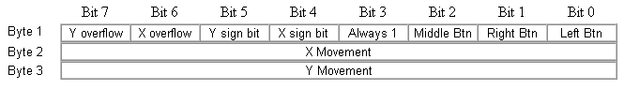
Figure 18. Data movement packet format (scrolling mode disabled)
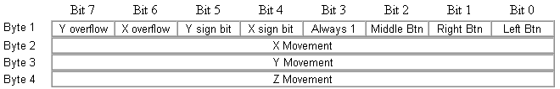
Figure 19. Data movement packet format (scrolling mode enabled)

The first received byte contains the state of the buttons on the least significant 3 bits. If one of this bits is high, then the corresponding mouse button is pressed, else it is released. The X and Y sign bit is the most significant bit of the x and y movement value. The x and y movements are represented on 9 bits, 2’s complement encoding. Thus, the range of the movement is -256 to 255. The movement sent for either axis is the delta movement from the mouse’s last position. The mouse does not keep track of the absolute position of the mouse. The controller uses the delta movements received to keep track of the absolute position, by adding these delta values to the last mouse position.

The mouse uses for the axes origin the lower-left corner, meaning the mouse will report a positive delta movement on x when moved right and negative (x sign bit is ‘1’) when moved to the left. When the mouse is moved upward, the y delta movement will be positive, and when moved downward, it will be negative. The monitor uses the upper-left corner for the axes origin. This means the y axis is inverted for the monitor relative to the mouse. The controller negates the value of the y movement before adding it to the previous y position to report the movement relative to the monitor axes origin, simplifying work for its client that want to display the mouse on screen.
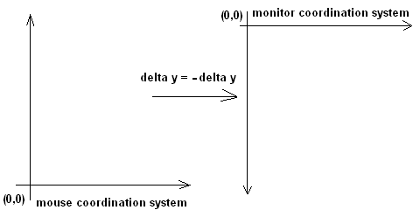
Figure 20. Y axis inversion
The current position of the mouse can be set at any time, by placing the desired horizontal (or vertical) position (relative to the monitor axes origin) on the ‘value’ input and set the ‘setx’ input signal (‘sety’ for the vertical position) high for one clock period. Similarly, the upper bounds of the mouse can be set by placing the value of the upper bound on the ‘value’ input and placing ‘setmax_x’ or ‘setmax_y’ high for one clock period. This is done when the resolution changes to place the mouse cursor (its hot-spot) in the middle of the screen and to prevent the cursor from leaving the visible area.

Figure 21. Set mouse position and bounds timing diagram
The outputs of the controller are:
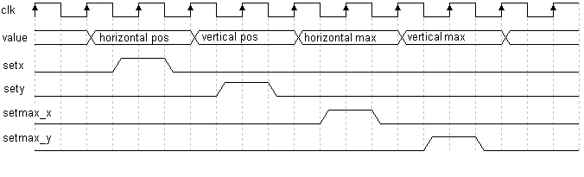

- left - state of the left mouse button (‘1’ if pressed, else ‘0’)
- middle - state of the middle mouse button (‘1’ if pressed, else ‘0’)
- right - state of the right mouse button (‘1’ if pressed, else ‘0’)
- xpos - 9 bits that hold the current horizontal position of the mouse
- ypos - 9 bits that hold the current vertical position of the mouse
- zpos - 4 bits that hold the last z delta movement received.
- new_event - high for one clock period after a new data movement packet
- is received and processed.

See the finite state machine state diagram for the mouse_controller on the next page.

The resolution_mouse_informer module is written in VHDL and it sets the position of the mouse and the bounds for it when the resolution changes. It waits in the idle state of its fsm for the switch input to become active and then it transitions through a sequence if states that place the desired position or bound on the value output and activates the corresponding set signal (setx, sety, setmax_x, setmax_y).

The mouse_displayer module is written in VHDL and generates a cursor to be displayed on the screen. The cursor is placed on a layer that is above the image to be displayed, it is a hardware cursor. It receives as inputs the current position of the mouse, the position on screen of the currently displayed pixel, the blank signal, the color channel data to be displayed from the underlying layer (the image layer) and obviously the global clock signal.

The cursor is 16 pixels width and 16 pixels height and represents an arrow. The hot-spot is the upper-left corner, and the cursor uses 1 color bit (black or white) and one 1 alpha channel bit (transparent or opaque). So every pixel in the cursor has 2 bits, of which the least significant is the color bit (0 for black and 1 for white) and the other is the transparency bit (0 for opaque and 1 for transparent). Transparency is needed for the cursor not to look as a 16 by 16 square, the background of the cursor (where the arrow is not) must be transparent to show the pixels of the underlying image. The arrow is white with a blank outlining to be visible on every image, no matter what color.
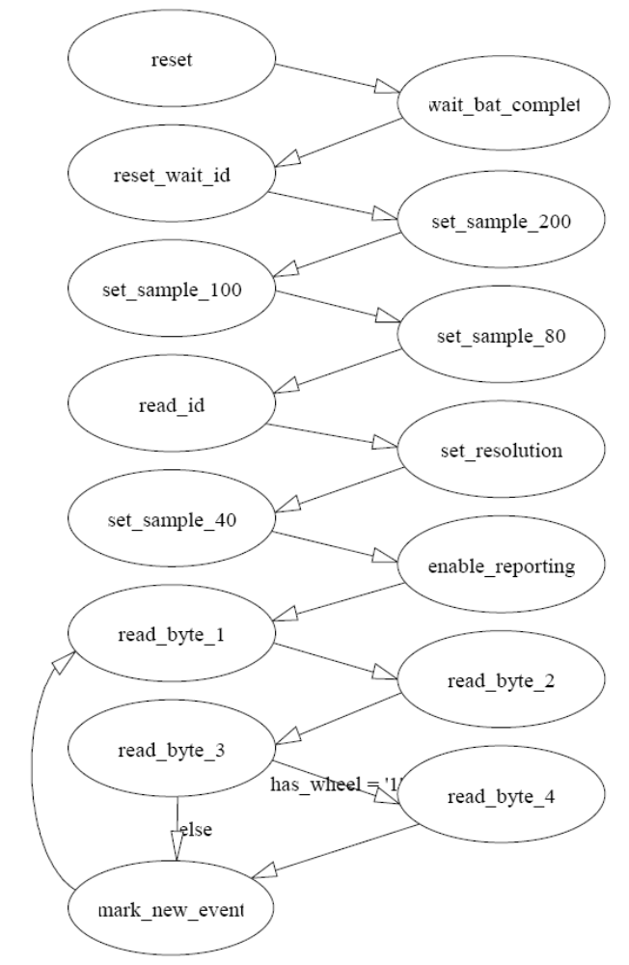

Figure 22. Mouse_controller fsm state diagram

Note: not all states have been represented and some state names have been changed to suggest the role of the sequence of states that it stands for. States that wait for acknowledge from the mouse are not included and the sequence of states the send a command followed by the actual data byte (like set resolution) are resumed to a single state in this diagram. Also, the transitions to the reset state when an error occurs are not figured.

The cursor image is kept in a 256x2bit ROM. When the hcount and the vcount are within the range [xpos, xpos+16) and [ypos,ypos+16) the mouse pixels are displayed instead of the pixels received at input (except where transparency is enabled). The difference on the x axis and the y axis are computed by subtracting the xpos from the hcount and ypos from vcount. The differences stored on 4 bits, and concatenated (ydiff & xdiff) are used to address the ROM and retrieve the current pixel to be displayed. This induces a delay in the pixels shown on the screen of one pixel clock, delay accounted for by delaying the blank signal with the same amount. This way the mouse cursor never completely leaves the screen. When blank input is active, the output color is 0 (black), no matter what pixel is received from the image layer.

The image_controller is written in VHDL and its responsibilities are to store the received bytes from the epp_data_module, to display the image when hcount and vcount are within the image bounds (or the background otherwise). Its interface consists of many input and output signals described in the following table.

Port Name | Port Direction | Description
clk | input | Global clock signal
rst | input | Global reset signal
btn | input | pulse from the button 1 of the Nexys Board when the button is pressed. The pulse is formed by passing the input signal from the button through the pulse_debouncer module.
pixel_color_in<3:0> | input | 4 bits representing the data for the current color channel sent by the epp_data_module.
write_pixel_color_in | input | input pin, from the command_dispatcher, active high for one clock period when new color channel data available on the pixel_color_in bus.
clear_write_counter_in | input | When active, it resets the write address counter in the image memory.
hex1_out<7:0> | output | data that will be displayed on the 2 right most 7-segment displays.
hex2_out<7:0> | output | data that will be displayed on the 2 left most 7-segment displays.
pixel_clk | input | currently used pixel clock signal, from the pixel_clock_switcher.
hcount | input | horizontal pixel counter from the vga_module
vcount | input | vertical pixel counter from the vga_module
red_out<3:0> | output | red color channel data sent to screen
green_out<3:0> | output | green color channel data sent to screen
blue_out<3:0> | output | blue color channel data sent to screen
inside_image | output | when active means that currently displayed pixel is part of the image, not of the background.
counter_out<1:0> | output | 2 bit value of the counter that gives what position to show on the 7-segment displays.
HMAX<9:0> | input | number of visible pixels in a line
VMAX<9:0> | input | number of visible lines in a frame
IMAGE_START_POS_H<9:0> | input | horizontal position of the upper-left corner of the image
IMAGE_START_POS_V<9:0> | input | vertical position of the upper-left corner of the image
IMAGE_END_POS_H<9:0> | input | horizontal position of the lower-right corner of the image
IMAGE_END_POS_V<9:0> | input | vertical position of the lower-right corner of the image
NUM_PIXELS_IN<13:0> | input | Total number of pixels in the image.
NEW_NUM_PIXELS_IN | input | High for one clock period when setting the total number of pixels in the image.

Groups of 4 bits are received from the epp_data_module representing the value of the current data channel sent. A pixel has 12 bits and consists of 3 such groups. The first channel sent in a pixel is the blue channel, then the green and finally the red channel. The image is stored entirely in the block ram, and the block ram resources are entirely dedicated to holding the image, for the image to be as large as possible. The RAM holding the image is a dual ported block ram, 16k entries of 12 bits width. This means that images up to 16384 pixels can be stored. There is no restriction on the aspect ratio used, other than the width must be a multiple of four and both the width and the height must be at most 256 pixels (to fit in a byte sent through the epp interface; to the byte sent, 1 must be added). This is a restriction of the software sending the image. DIB images (device independent bitmap, used by the software) with width not multiple of 4, have added pixels on each line to pad to a width that respects this restricting. These pixels are hidden, and the software sending the image does not account for them. This is why the sent image must have the width multiple of four. It is not the hardware that places this restriction.

Only when a pixel is entirely received it is written into memory. The received channel data is stored in the 12 bit register called “pixel”, and when the red channel is received and stored, the content of pixel is written to memory.

Figure 23. Format of pixel register.

To receive the color channel data and manage writing in memory a finite state machine is used with the following state diagram.
Figure 24. Image_controller fsm state diagram
Pixels are written in the memory in a sequential order, one after another, at consecutive addresses. After writing a pixel in memory, the writepos address counter is incremented.

Before receiving a new image, the command_dispatcher sets high the clear_write_counter_in signal, and the writepos counter is reset, for the image to be written from the beginning of the memory array.

Reading from memory is also done in a sequential manner. The readpos address counter is incremented after one pixel is read, to be sent to the monitor. This is FIFO like behavior because the read address is not composed from the hcount and the vcount, instead, the next pixel on line is read. Reading is done at pixel_clk frequency and writing is done at (system) clk frequency.
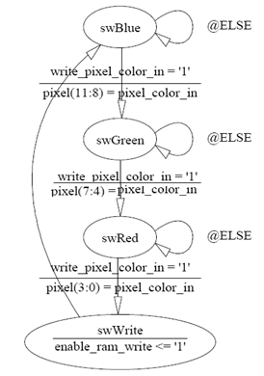

Memory reading is enabled only when the hcount and the vcount are inside the bounds of the image, bounds presented on the IMAGE_(START/END)_POS_(H/V) inputs. Outputting the pixels from memory is delayed one pixel clock from when the vga counters enter image bounds to allow time for the memory to fetch the pixel. This introduces a one pixel clock period delay in displaying the current pixel, but this is accounted for by also delaying with the same amount the blank signal. When not displaying the image, white background color is sent on the color outputs.

Not all images fill the memory. So after reading the last pixel from the memory, the readpos counter must be reset. The reset is done when hcount = HMAX and vcount = VMAX. The hex1_out and hex2_out output pins are used to display a number on the 7-segment displays, representing one of the four values describing the image bounds: horizontal value of the upper-left corner (IMAGE_START_POS_H), vertical value for this corner (IMAGE_START_POS_V), horizontal value for the lower-right corner (IMAGE_END_POS_H) and vertical value for this corner (IMAGE_END_POS_V).
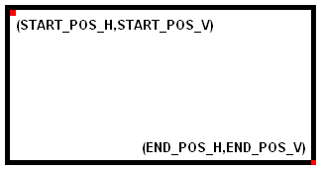
To select which position to display, button 1 on the Nexys board must be pressed. This will increment the “counter” (2 bits) and selects the next position to display. The counter value is output on “counter_out” pins and are tied to leds 7 and 6 of the board.

Figure 25. Image bounds

Counter Position displayed

- horizontal position of upper-left corner
- vertical position of upper-left corner
2 horizontal position of lower-right corner
3 vertical position of lower-right corner

The image_motion_controller is written in VHDL and is responsible for interpreting mouse gestures and changing the position of the image on the screen. It receives the mouse position from the mouse_module, the buttons state, z movement of the wheel, the width and the height of the image from the command_dispatcher, the currently used resolution and it generates the image bounds and sends it to the image_controller.

When a new image is sent, the image motion controller receives the width and the height of the image, from which it computes the image bounds so that the image is centered, which it then outputs for the image controller to use the new bounds. The width and height received are in the range 0-255 to fit in 8 bits. To this value 1 must be added to find the actual width or height of the image. When the resolution is changed, the image is centered.

The controller identifies mouse dragging of the image, and computes new the image position every time the mouse is moved while holding the image. This is done by saving the difference from where the mouse cursor was clicked inside the image to the upper-left corner of the image, and then, when the mouse moves, subtracting this difference from where the mouse currently is, to obtain the upper-left corner of the image. Adding the width and height to this position give the complete bounds of the image. The computation of the image bounds uses saturation, meaning the image will not leave the visible part of the screen; it won’t go over the screen edge.
The computation takes place in two stages (two consecutive clock periods) because making it only in one clock period would decrease the maximum frequency the design could run well under 100MHz. For this reason, a multistage computation is used. To handle this, a small finite state machine with only 3 states is used, as shown in the diagram bellow.

In stage 1, the new image bounds are computed, without taking into account saturation. During stage 2, the values from the first stage are saturated, for the image bounds to be inside the visible screen.
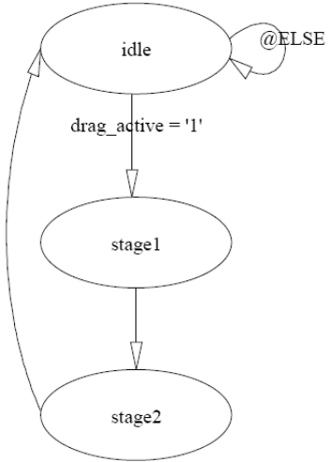
Figure 26. Multistage computation FSM

Also, the image can be moved by rolling the wheel. When the mouse wheel is rolled, the image is moved up or down on the screen, the increment being 8 pixels for every z movement event. To move the image sideways, the middle button must be held down while rolling the wheel.

The last module represented is the effects_layer module, written in VHDL. This module applies the negative, grayscale or both effects to the image received from the image_controller. The effect to apply is selected using the keyboard. Keyboard events are received from the keyboard controller and if the users presses N key, the negative effect is applied to the output image. If G key is pressed, the grayscale effect is applied. Keys N and G toggle if the corresponding effect is applied or not. Both effects can be applied simultaneously.

The effect is not applied to the background, because it applies only to pixels for which the inside_image input is active. Because the effects_layer is placed between the image_controller and the mouse_displayer, the effects are not applied to the mouse.

The negative effect is done easily by negating the value of the incoming pixels (xor-ing them with 1). The grayscale effect is applied by multiplying the value of each color channel with a corresponding weight, adding the products and assigning the sum to all the color channel. The weights for the color channels are:

0.30 for red
0.58 for green
0.12 for blue

The weights are proportional to the wave length of the corresponding light wave. For multiplying a channel with its corresponding weight, the values of the channels are multiplied with integers, the product is added and the least significant 9 bits are discarded, effectively dividing the sum by 512. The integers must add up to 512 and each integer divided by 512 must give the corresponding weight between 0 and 1. Values used are: 154 for red, 298 for green and 60 for blue.

Example: for a pixel with (r,g,b) = (10,8,15) the value of the pixel after applying the grayscale is (9,9,9). (10 * 154 + 298 * 8 + 15 * 60)/512 = 9 (rounding down).

Example image and results of applying the effects:

Original Image Negative Applied Grayscale Applied Both Applied



3. Discussion

This is a relatively complex design, and consequently uses a lot of the FPGA’s resources.
Logic Utilization | Used | Available | Utilization(%)
Number Of Slices | 1115 | 1920 | 58
Number Of Slice Flip Flops | 887 | 3840 | 23
Number Of 4 Input LUTs | 1766 | 3840 | 45
Number Of Bonded IOBs | 54 | 173 | 31
Number Of BRAMs | 12 | 12 | 100
Number Of Mult18x18s | 1 | 12 | 8
Number Of GCLKs | 4 | 8 | 50
Number Of DCM_ADVs | 2 | 4 | 50

Notice that the Block Ram resources are entirely used, and all the block rams hold the image. Every other signal that inferred a block ram, was forcibly made to use distributed ram through the use of VHDL attributes.

Timing Summary:
---------------
Speed Grade: -4

Minimum period: 19.918ns (Maximum Frequency: 50.206MHz)
Minimum input arrival time before clock: 7.716ns
Maximum output required time after clock: 10.825ns
Maximum combinational path delay: No path found

Although the maximum frequency specified is 50.206MHz this is not the real maximum frequency that the project can be used at. The project works fine at 100MHz. When detailing where the maximum delay appears, xst gives the following:

Delay: 9.959ns (Levels of Logic = 15)
Source: iVGA_MODULE/iVGA_800_60/hcounter_0 (FF)

It is my assumption that this is a bug in the synthesizer, brought forward by the use of DCM device primitives treated as black boxes and clock switching techniques.

The design was created for the Digilent Nexys board, with a Spartan-3 200K FPGA, speed grade -4 and ft256 package (xc3s200-4ft256). It was not tested on other boards, but it should run fine on any Spartan-3 device.

For further reference for this project, please consult the comments in the source files. They are generously commented and hopefully insightful.

4. References

Design files are located in the following directories:

Webpack Project: BRIV\Hardware
C# Project : BRIV\Software
Documents : BRIV\docs

Design tools used include:

Computer/OS: Pentium class/WinXP service pack 2
Schematic capture: Xilinx Webpack 7.1.04i
Simulation: ModelSimXE III 6.0d Starter Kit, free version
Documentation: Microsoft Office Word 2003, MS Paint, StateCad

Recommended articles on the web, relevant for this project:

http://www.beyondlogic.org/epp/epp.htm - Description of the EPP interface
http://www.computer-engineering.org/ps2protocol/ - Description of the PS/2 Protocol
http://www.computer-engineering.org/ps2keyboard/ - Description of the PS/2 Keyboard
- interface
http://www.computer-engineering.org/ps2mouse/ - Description of the PS/2 Mouse
- Interface
http://www.epanorama.net/documents/pc/vga_timing.html - VGA timing reference

